

Requirement & analysis report

Verklegt námskeið 1

LEiðbeinandi: Sveinn Arnar Stefánsson

Hlynur Magnússon ([hlynur18@ru.is](mailto:hlynur18@ru.is))

Snorri Vignisson ([snorrivig18@ru.is](mailto:snorrivig18@ru.is))

Sveinbjörn Jóhannesson ([sveinbjornj18@ru.is](mailto:sveinbjornj18@ru.is))

Tekla Kristjánsdóttir ([tekla18@ru.is](mailto:tekla18@ru.is))

Table of content

1 Introduction 3

2 Requirement list 4

3 Use Cases 5

3.1 Use case 1 5

3.2 Use case 2 6

3.3 Use case 3 7

3.4 Use case 4 7

3.5 Use case 5 8

3.6 Use case 6 8

3.7 Use case 7 9

3.8 Use case 8 10

3.9 Use case 9 11

3.10 Use case 10 12

3.11 Use case 11 13

3.12 Use case 12 13

4 Description of user group 14

5 Wireframes and interviews 15

5.1 Prototype before interviews 15

5.2 Interview setup: 18

5.3 Interview 1: 19

5.3.1 Examples of changes made with consideration to Rökkvi’s comments: 20

5.4 Interview 2: 22

5.5 Interview 3: 23

5.6 Interviews epilogue: 23

5.7 Prototype after interviews 24

6 Comparison to similar systems 27

7 Use case diagram 29

8 Conclusion 30

# Introduction

In this project we are creating a software for employees at a car rental that handle the rental and returns of cars. The software will also include databases for the cars, the customers and the rental history of the company. It is designed for a company with at least 3 types of car classes. The minimum rental period is one day, and the customer can pay with cash, credit or debit.  In this requirement analysis report we will put up a requirement list, use cases and a description of the user groups. Also, we will make prototype sketches of the software and take interviews with people to give us feedback on the sketches that we made. After the interviews we will adjust our prototype with points taken from the feedback.

# Requirement list

# Use Cases

## Use case 1

|  |  |
| --- | --- |
| Name | User rents out a car to customer. |
| Number | 1 |
| Priority | A |
| Precondition | * User is in the system. * Customer is registered in the customer database. |
| Description | * User selects “Rent a car” on the home screen. * Customer picks a certain type of car for rental. * User assigns the car to the customer for a certain time period. * User calculates the cost of the rental. * User prints out rental contract on the screen and shows the customer. * The user asks the customer how he will pay for the rental car. - Debit card/Credit card/Cash: User pays on the spot. |
| Alternative flow | * The car is not available for the desired time period. - The user can offer him another car of a different type, if another car is available. - The user can offer him the same type of a car for another time period. * Customer wants extra insurance, go to use case 10. * The customer doesn’t have a way of paying. - The customer must come later when he can pay. |
| Post condition | * The car is now not available for other customers. * The rental of the car is assigned to the customers history, the car’s history and the company’s rental database. |
| Source | 1, 3, 5, 6, 14, 15, 16. |
| Actor | User and customer. |
| Author | Hlynur Magnússon and Sveinbjörn Jóhannesson. |

## Use case 2

|  |  |
| --- | --- |
| **Name** | Customer returns a car. |
| **Number** | 2 |
| **Priority** | A |
| **Precondition** | * User is in the system. * Customer must have an active rental of a car. * Customer must be a registered customer. |
| **Description** | * User selects “Return a car” on the home screen. * User searches for customers rental information. * User checks for extra cost. - Time period was longer than agreed. - The car was damaged. - Car was not returned with a full tank of fuel. * User prints out the rental contract with any changes in extra cost and shows the customer on the screen. * Customer payment if needed. - Debit card/Credit card/Cash: User pays on the spot. |
| **Alternative flow** | * Customer does not have the car anymore, lost/stolen. - Customer must contact his insurance company if he has one. He must pay for the car in one way or another. * Customer returns the car before deadline because of a damage to the car or malfunction, if the damage is not covered by insurance the customer must pay for it. Otherwise the company does. - The user can rent him another car for the rest of the time period, go to use case 1. * Customer has lost the car keys. - If the customer has the “lost car keys insurance”, he will only have to pay for the deductible insurance otherwise he’ll have to pay for a new car key. |
| **Post condition** | * Car will go through a maintenance schedule that takes one day. After that he will be available for rental. - If car was damaged the maintenance schedule will take 5 days. * Customer has payed for the rental of the car. And any extra cost if needed. |
| **Source** | 2, 5, 6, 16, 17. |
| **Actor** | User and customer. |
| **Author** | Hlynur Magnússon and Sveinbjörn Jóhannesson. |

## Use case 3

|  |  |
| --- | --- |
| **Name** | User checks for available cars. |
| **Number** | 3 |
| **Priority** | A |
| **Precondition** | * User is in the system. |
| **Description** | * User selects “Available cars” on the home screen. * User gets a list of cars that are available for rental. |
| **Alternative flow** | * No cars are available for rental. - System prints out “No car available!” |
| **Post condition** |  |
| **Source** | 3, 15. |
| **Actor** | User. |
| **Author** | Hlynur Magnússon and Sveinbjörn Jóhannesson. |

## Use case 4

|  |  |
| --- | --- |
| **Name** | User adds customer to the customer database. |
| **Number** | 4 |
| **Priority** | A |
| **Precondition** | * User is in the system. * User has the customers information. |
| **Description** | * User selects “Customer database” on the home screen. * User selects “Add customer”. * User types in the customers information and saves it to the database. |
| **Alternative flow** | * Customer is already in the customers database. - The system prints out “Customer already exists, do you want to overwrite that customer?” |
| **Post condition** | * Customer is in the customer database. |
| **Source** | 4, 12. |
| **Actor** | User and customer. |
| **Author** | Hlynur Magnússon and Sveinbjörn Jóhannesson. |

## Use case 5

|  |  |
| --- | --- |
| **Name** | User can calculate the cost of a rental. |
| **Number** | 5 |
| **Priority** | A |
| **Precondition** | * User is in the system. * User has information about the said rental. * User has access to the price list of rental cars. * User has a way of calculating the price. |
| **Description** | * User can give the customer an option for extra insurance, go to use case 10. * User compares the said rental information to the price list and calculates the total price. |
| **Alternative flow** | * User does not have the rental information - User must get the rental information from the customer. |
| **Post condition** | * User has the total price of the said rental. With chance of extra cost when the car is returned. |
| **Source** | 5, 6, 14. |
| **Actor** | User. |
| **Author** | Hlynur Magnússon and Sveinbjörn Jóhannesson. |

## Use case 6

|  |  |
| --- | --- |
| **Name** | User can display the price list. |
| **Number** | 6 |
| **Priority** | A |
| **Precondition** | * User in the system. * Price list is set up in the system. |
| **Description** | * User selects “Price list” on the home screen. |
| **Alternative flow** | * Price list is not set up in the system. - User must set up the price list in the system. |
| **Post condition** | * The price list is displayed on the computer screen. |
| **Source** | 6. |
| **Actor** | User. |
| **Author** | Hlynur Magnússon and Sveinbjörn Jóhannesson. |

## Use case 7

|  |  |
| --- | --- |
| **Name** | User can search the customer database |
| **Number** | 7 |
| **Priority** | B |
| **Precondition** | * User must be in the system. * System must have a customer database. |
| **Description** | * User selects “Customer database” on the home screen. * User selects “search customer database”. * User searches for a customer by typing in name or SSN. * User gets numbered list of customers (basic info shown) that fit the search. * User picks the customer they want to view. - The computer prints out all the information about that customer. * User gets the option to select. - Change customer information. - Unregister customer. - Exit search. * If user picks change customer information, user will go to use case 8 and then refresh current use case (7). * If user picks unregister customer, user will go to use case 9 and then refresh current use case (7). * If user picks exit search, user will go to the “Customer database” page. |
| **Alternative flow** | * The search criteria the user typed in does not match any customer in the customer database. - The computer displays “No match!” and refreshes current use case. |
| **Post condition** | System back to “Customer database” |
| **Source** | 10. |
| **Actor** | User. |
| **Author** | Hlynur Magnússon and Sveinbjörn Jóhannesson. |

## Use case 8

|  |  |
| --- | --- |
| **Name** | User can change a customer’s information in the customer database. |
| **Number** | 8 |
| **Priority** | B |
| **Precondition** | * User must be in the system. * User must have come from use case 8. |
| **Description** | * The computer displays “What would you like to change?” on the screen. * The computer displays a list of all attributes that can be changed with the option to change nothing and exit. * If the user selects to change anything, the computer asks for an input to change that. Then it asks you if you’re sure you want to change that information. If you accept the changes the information of the customer will be changed, and the user will be asked if he would like to change anything else or just exit. And that will happen again and again until the user doesn’t want to change anything more about the user. |
| **Alternative flow** | * You are not allowed to change something in the customers information e.g. the SSN. - The computer will display: “You cannot change the SSN.” |
| **Post condition** | * If any changes were made to the customers information, they will be saved in the customers database. * The user will be sent back to the customer database page. |
| **Source** | 10, 12. |
| **Actor** | User. |
| **Author** | Hlynur Magnússon and Sveinbjörn Jóhannesson. |

## Use case 9

|  |  |
| --- | --- |
| **Name** | User can unregister customer from customer database |
| **Number** | 9 |
| **Priority** | B |
| **Precondition** | * User must be in the system. * User must have come from use case 8 |
| **Description** | * User searches for a customer by name or SSN. * User selects the option to unregister the customer. |
| **Alternative flow** | * The user is not in the system. - The user must open the system. * The customer is not in the database. - The computer displays “Customer doesn’t exist.” and askes if you want to create a new customer. If user decides to create a new customer, he will go to user case 4.  - If the user doesn’t want to create a new customer he will go back to the previous page. |
| **Post condition** | * The costumer has been removed from the costumer database. * The user will be sent back to the customer database page. |
| **Source** | 7, 10. |
| **Actor** | User. |
| **Author** | Hlynur Magnússon and Sveinbjörn Jóhannesson. |

## Use case 10

|  |  |
| --- | --- |
| **Name** | User can give costumer further insurance |
| **Number** | 10 |
| **Priority** | B |
| **Precondition** | * User must be in the system. * Costumer must be in costumer database. |
| **Description** | * Costumer wants to rent a car and wants extra insurance. * User adds further insurance to the rented car. * Then costumer rents car, he will go to use case 1. |
| **Alternative flow** |  |
| **Post condition** | * Price of further insurance has been added to total price |
| **Source** | 1, 5, 6, 14. |
| **Actor** | User and Costumer. |
| **Author** | Snorri Vignisson. |

## Use case 11

|  |  |
| --- | --- |
| **Name** | User can display all cars that are out on rental |
| **Number** | 11 |
| **Priority** | B |
| **Precondition** | * User must be in system. |
| **Description** | * User selects “Rental database” on the home screen. * User selects “Car’s on rental now”. * A display of all cars being currently rented pops up. * View all rented cars. * Exit display. |
| **Alternative flow** | * No cars are in a “rented” state and instead of displaying a list of rented cars it displays “No cars are rented at the moment”. |
| **Post condition** | * Back to “Rental database”. |
| **Source** | 8, 9. |
| **Actor** | User. |
| **Author** | Snorri Vignisson. |

## Use case 12

|  |  |
| --- | --- |
| **Name** | User can display rental history of the company |
| **Number** | 12 |
| **Priority** | B |
| **Precondition** | * User must be in system. |
| **Description** | * User selects “Rental database”. * The computer displays a list of all rentals made by the company. Listed by date of beginning of rental. * User can view the list for as long as wanted. After that he will select the exit option. |
| **Alternative flow** | * The company has no rental database. - The computer displays: “No rental history!” |
| **Post condition** | * Back to home screen. |
| **Source** | 8, 9. |
| **Actor** | User and Costumer. |
| **Author** | Sveinbjörn Jóhannesson. |

# Description of user group

A screenshot of a cell phone


# Wireframes and interviews

## Prototype before interviews

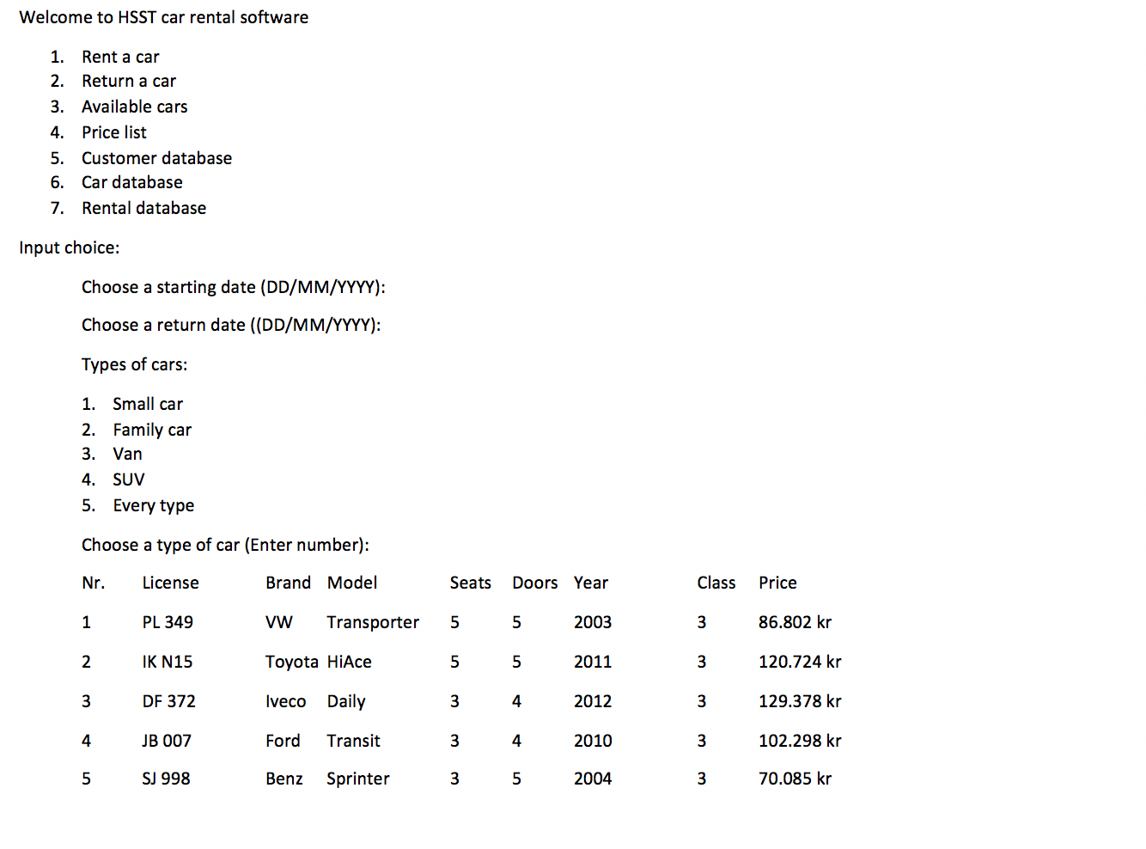

A screenshot of a cell phone

Description automatically generatedA screenshot of a cell phone


A screenshot of a cell phone

Description automatically generatedA screenshot of a cell phone

Description automatically generatedA screenshot of a cell phone


## Interview setup:

We will ask the interviewee a couple questions about his background and then have him go through our prototype and finish a small project as a user of the software. After that we will discuss his experience of the software and what he would do better.

Basic info questions:

1. What is your name?
2. How old are you?
3. What is your education?
4. Have you worked at a car rental or a similar place?
5. What is your current job?

Project for the interviewee:

You will be a user of a software and the questioner will be a customer that wants to rent a car.

The customer is a new customer that wants to rent a van (Iveco Daily) and be the only driver. He wants the insurance package number 1 and to pay with cash.

Time period of rental: 22/04/2019 – 29/04/2019

Epilogue:

1. Was there anything that you thought was unclear about this software’s functionality?
2. Is there anything that you would change?
3. Do you have a good name for the software?

## Interview 1:

Basic info:

1. Rökkvi
2. 21-year-old.
3. Finished upper secondary school, now a student at Reykjavík University.
4. Has worked at a car rental (AVIS).
5. Not working, student.

Adjustments on prototype:

1. Change tablet of car info.
2. Auto create new customer if customer is not registered.
3. Make names of insurance packages clearer.
4. Make a possibility to edit order afterwards rather than accept everything twice.
5. More information on order confirmation, especially regarding insurance packages and what they include.
6. Combine the order overview and order confirmation, don’t print out similar things like that twice. Rather make one more detailed order confirmation.
7. On order confirmation, add price per day for rental and insurance.
8. Add driver’s license ID, and the availability to register a credit card to the customer.

Epilogue:

1. Nothing unclear, easy to use.
2. See adjustments on prototype.
3. No name idea.

### Examples of changes made with consideration to Rökkvi’s comments:

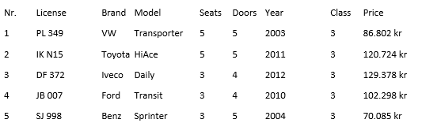

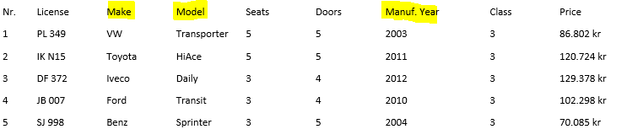

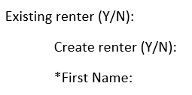

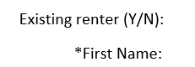

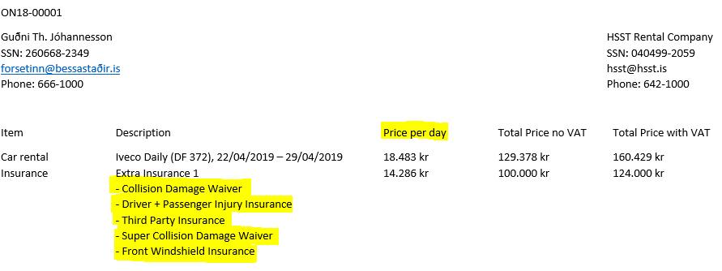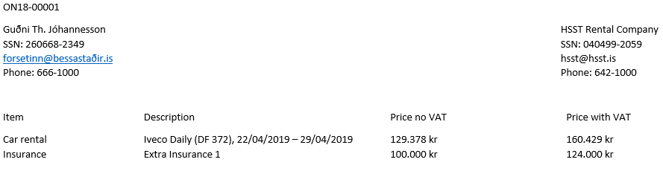

## Interview 2:

Basic info:

1. Arndís
2. 20-year-old.
3. Finished upper secondary school, now a student at Reykjavík University.
4. Hasn’t worked at a car rental or similar workplace.
5. Basketball coach for Breiðablik.

Adjustments on prototype:

1. Make clearer where you’re typing in on home screen.
2. Change existing renter to existing customer, not clear what renter is.
3. Be more clear what fields are required in creating a customer.
4. Insurance tablets complicated.
5. Payment method needs a point of input.

Epilogue:

1. Mainly just insurance tablets.
2. See adjustments on prototype.
3. No name idea.

**Examples of changes made with consideration to Arndís’s comments:**

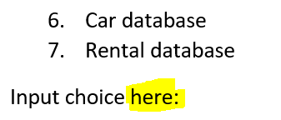

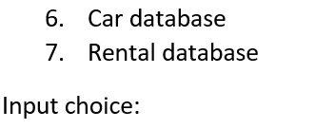

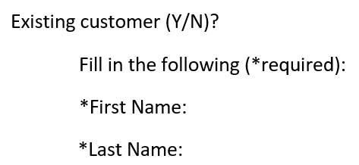

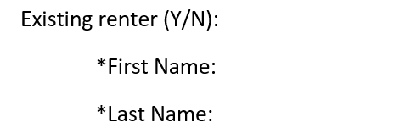

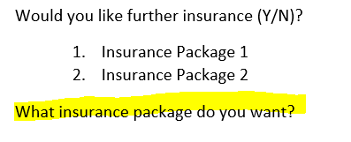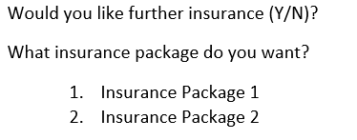

## Interview 3:

Basic info:

1. Magnús Ingi Gylfason
2. 20-year-old.
3. Finished upper secondary school.
4. Hasn’t worked at a car rental.
5. Works at the Toyota agency in Iceland as a car salesman.

Adjustments on prototype:

1. Insurance tablets to complicated, make more user friendly.

Epilogue:

1. Mainly just insurance tablets, again.
2. See adjustments on prototype.
3. No name idea.

No major changes were made after this interview.

## Interviews epilogue:

After taking three interviews we have made some changes to our prototype. The only thing we have not changed so far is the insurance tablets. We will make further changes to them later in the process we do not think that is important at this point, because for now we are only thinking about easy access and the software’s functionality.  
With this requirement analysis report there will be two attachment with the prototype before interview and after all interviews.

## A screenshot of a cell phone Description automatically generatedPrototype after interviews

A screenshot of a cell phone


A screenshot of a cell phone


A screenshot of a cell phone


A screenshot of a cell phone


# Comparison to similar systems

We looked at the system „Easy Rent Pro“ to get design ideas and to see how other similar systems work to be able to design the wireframes. We had this system in consideration through the whole process.

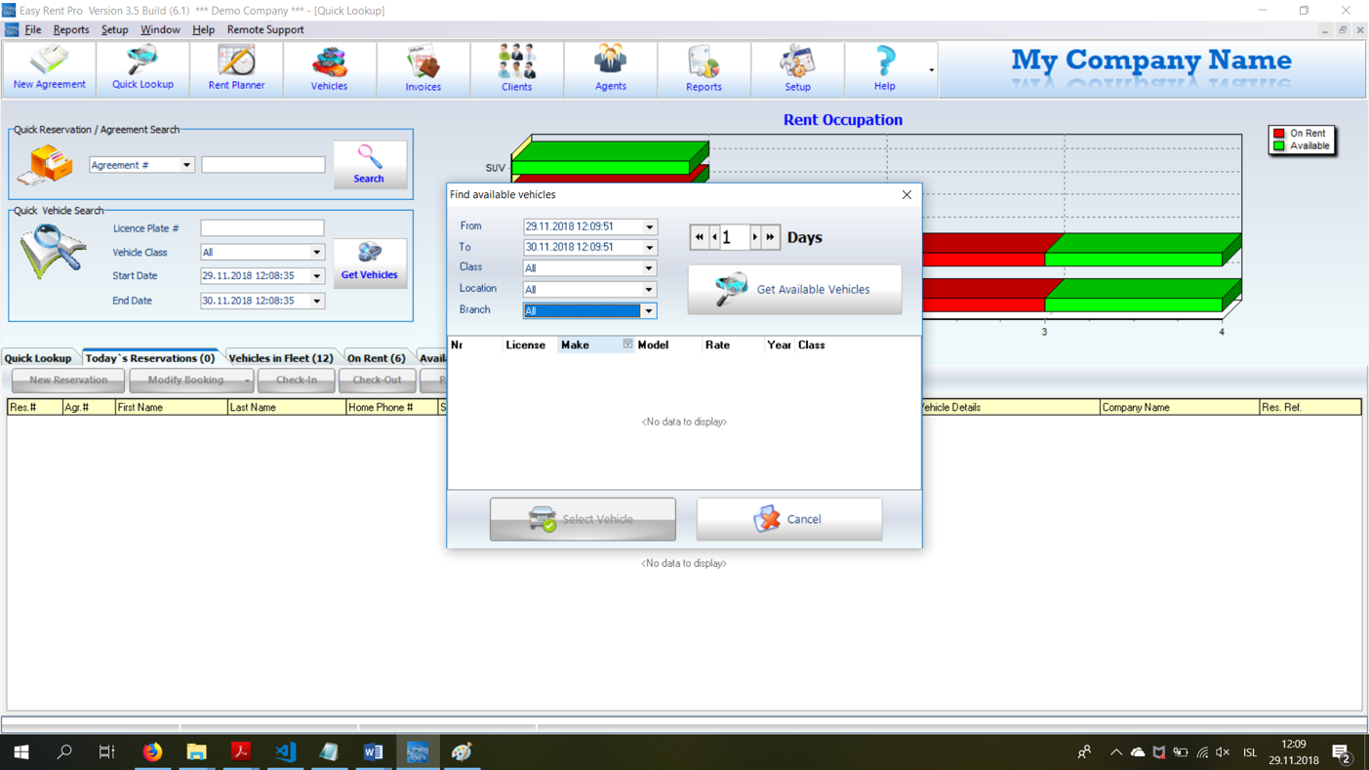

A screenshot of a computer


A screenshot of a computer


A screenshot of a computer


# Use case diagram

A close up of a map


# Conclusion

This project gave us a new insight of how a good and useful software can take a lot of work. It was interesting to see how the design ideas can change after getting new perspectives. We interviewed people with experience in car rentals to figure out what a car rental needs from its software and novices to see if it is user friendly to those with little to no experience of renting out cars. The constructive criticism from both parties has helped a whole lot with the development of the software and we clearly saw how important it is to get users involved in the process. Everybody did their part in this project and the teamwork was excellent.